FTH-HDLE TABLE OF COLORED PART

TABLE OF COLORED PART（New Blade 600 LT For EPS）2017
ITEM NO. | CODE | A
ITEM NO. | Basic Color | Gentry Gray
ITEM NO. | Description | GRA 709(YG)
21 | Front body cover | 512465EYG
21 | Glove compartment cover, LH | 512421YG
21 | Glove compartment cover, RH | 512422YG
21 | Carrier cover | 512425YG
21 | Reservoir cover | 512496
22 | Side cover, LH, With emblem | 511504YGLAR
22 | Side cover, LH | 511504YG
22 | Emblem | 518550YG
22 | Emblem | 518511YG
22 | Emblem | 518367
22 | Side cover, RH, With emblem | 511505AYGRAR
22 | Side cover, RH | 511505AYG
22 | Emblem | 518552YG
22 | Emblem | 518514YG
22 | Emblem | 518368
22 | Fuel tank cover, upper., With emblem | 512454YGFA6
22 | Fuel tank cover, upper | 512545YG
22 | Emblem | 518549YG
22 | Emblem | 518551YG
23 | Rear body cover | 514498XYG
23 | Carrier cover | 512425YG

I
FTH-HDLE (EPS) TABLE OF LABEL
Label | Drawing | Description
 | 518549YG | Emblem, Fuel tank cover, upper.
 | 518551YG | Emblem, Fuel tank cover, upper.
 | 518550YG | Emblem, Side cover, LH.
 | 518511YG | Emblem, Side cover, LH.
 | 518552YG | Emblem, Side cover, RH.
 | 518514YG | Emblem, Side cover, RH.
 | 518367 | Emblem, Side cover, LH.
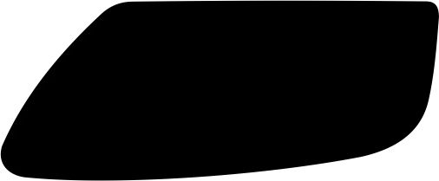 | 518368 | Emblem, Side cover, RH.

I

